Chairman Tim Doherty called the meeting to order at 7:03 PM.
Secretary Danielle Masse-Quinn called roll:
PRESENT ROLL CALL: Tim Doherty – present
James Bergeron – present
Roger Montbleau - present
Danielle Masse-Quinn – present
Joe Passamonte – present
Bruce Bilapka – present
Selectmen’s Representative Charlene Takesian – present
Alternate Paddy Culbert – present
Alternate Hal Lynde – present
Alternate Samuel Thomas - present
Alternate John Spottiswood – present
Kerry Karalekas - present
Recording Secretary Heidi Zagorski - present
NOT PARTICIPATING: Selectmen’s Alternate Representative Jaie Bergeron
Alternate Scott Sawtelle
Planning Director/Zoning Administrator Jennifer Beauregard
PLEDGE OF ALLEGIANCE
MOMENT OF SILENCE
Mr. James Bergeron held a moment of silence and prayer in remembrance of the 22nd Anniversary of 9/11 and for all those who lost their lives, all the first responders, and all the people who continue to suffer from the loss of their families.
MEETING MINUTES
The Board members had no changes or revisions to the August 21st, 2023 meeting minutes.
MOTION: (Passamonte/Bilapka) To approve the August 21st, 2023 meeting minutes as written.
VOTE: (7-0-0) The motion carried.
OLD BUSINESS
PL2023-00020
Map 41 Lot 10-246
SMOKE & FLAME HOOKAH LOUNGE, KALTSAS, Stephen (applicant) – MZL REALTY LLC (Owner) – 10 Bridge Street - Seeking Site Plan review to allow ‘Steve’s Street Meats’ food truck to be parked in the front left corner of the parking lot, or on the grass, in front of Smoke & Flame Hookah Lounge, for an extended period of time.
Mr. Stephen Kaltsas introduced himself from 60 Scott Street in Dracut representing his business Steve’s Street Meats, LLC.
Mr. Tim Doherty asked if he had anything new for the Planning Board. Mr. Kaltsas said there was a previous meeting that was held with the Highway Safety Department on August 28th, 2023. Mr. Doherty asked if any Board members had comments or questions.

Ms. Charlene Takesian said that based on the comments from the Highway Safety Department, they said “they felt the location of the truck shown on the plan provided was too close to the entrance into the plaza and not in a well-lit area. The committee did not support a stationary location of the vehicle since there were not any other Hawker and Peddlers who had permission to operate in this manner. They would support a Hawker and Peddler’s License to come and go daily provided it was moved back on the property in closer proximity to the building for patrons' safety.” Ms. Takesian added that the Highway Safety Department leaves it up to the Planning Board to stipulate hours of operation.
Mr. Paddy Culbert stated that there are two trash receptacles in the WCD (Wetland Conservation District) area. Mr. Culbert said the two trash receptacles and Steve’s Street Meat truck should not be allowed within the WCD. Mr. Doherty said any expansion of a business into the WCD is a problem and one of the reasons the Planning Board wants to hear from the Conservation Commission.
Ms. Danielle Masse-Quinn asked Mr. Kaltsas if he planned to go before the Conservation Commission. Mr. Kaltsas said he will be before the Conservation Commission on September 13th, 2023. Ms. Masse-Quinn said according to the minutes from the July 3rd, 2023 Planning Board meeting, the Planning Board made a motion for Mr. Kaltsas to go before the Conservation Commission. Ms. Masse-Quinn said that it looks like the building itself with the dumpsters is already encroaching on the WCD. Mr. Kaltsas said the dumpsters belong to the existing tenants and are not related to his business.
Ms. Masse-Quinn stated that there are no other trucks in town similar to Mr. Kaltsas and said she is not comfortable setting this precedent if it is not already allowed in town. Mr. Kaltsas asked why new businesses aren’t allowed to start and flourish in a town that doesn’t have anything like what he is offering.
Ms. Takesian stated that there are additional comments from the Planning Director, Jennifer Beauregard, and discussion from Police Chief Perriello, and the Highway Safety Director Hoffman.
Ms. Takesian said that they are not not allowing Mr. Kaltsas to grow and flourish, adding that Mr. Kaltsas has rented space within the building and he does not need to expand to the outside and that she would encourage Mr. Kaltsas to utilize the space he currently has. Mr. Kaltsas said he would have to invest $100,000 plus in the building to build a restaurant and come to code. Ms. Takesian said it is the same as everyone else would have to do.

Mr. Bergeron asked Mr. Kaltsas if he had the comments from the Planning Board packet. Mr. Bergeron suggested reading the comments into the record for the benefit of the applicant.
Ms. Masse-Quinn read the following comments from the August 28th, 2023 Highway Safety Department meeting into the record:
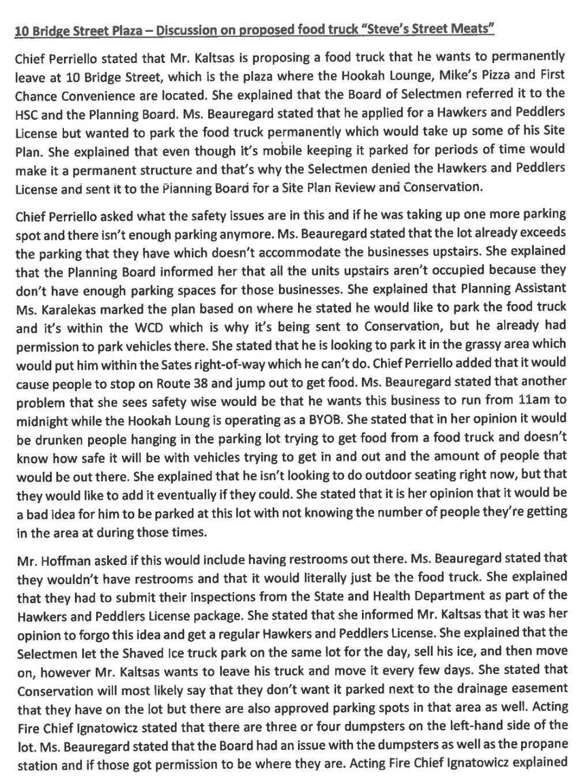
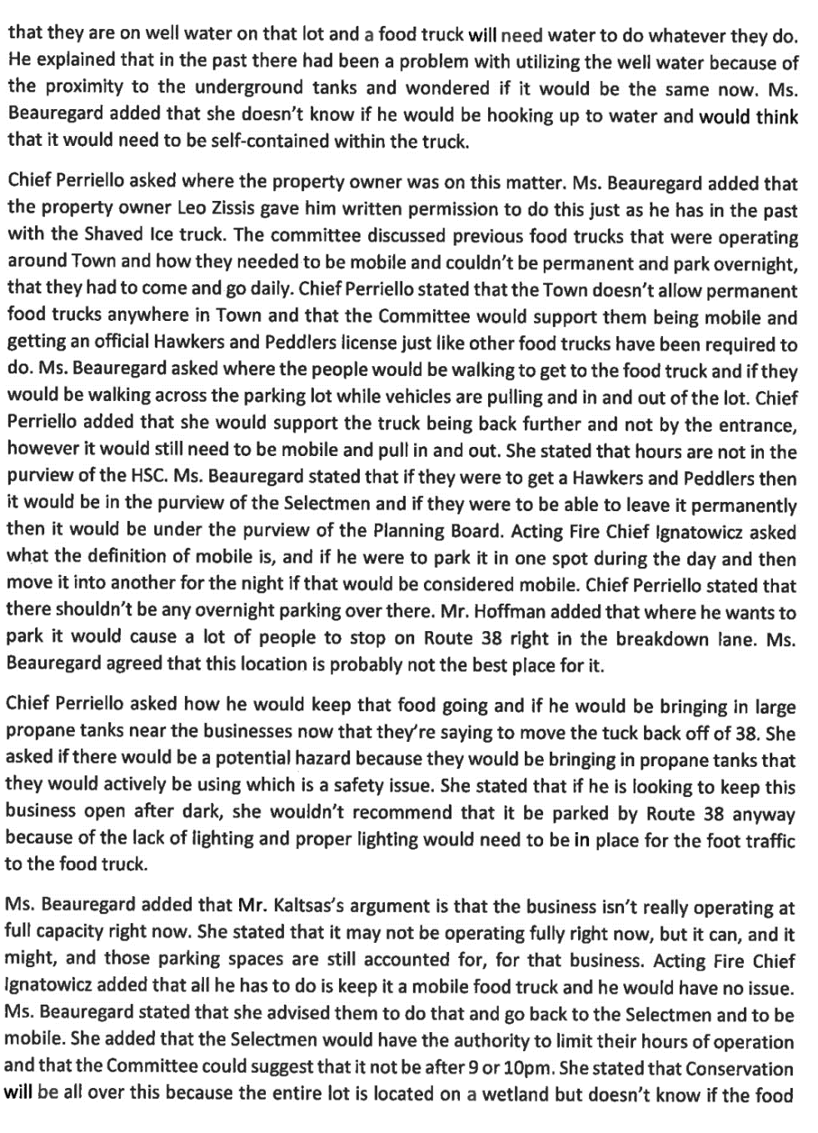
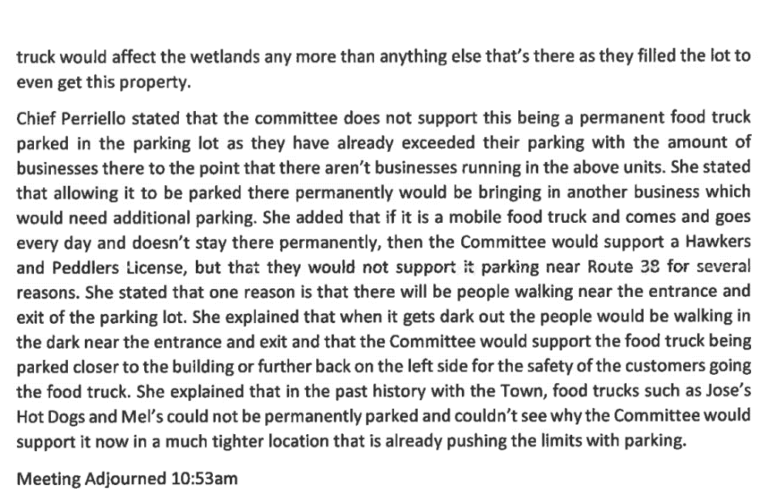
Mr. Doherty suggested a couple of additions and changes to the wording that could be made to clarify the August 28th, 2023 Highway Department Safety Meeting Minutes. Mr. Doherty said at the end of the first paragraph, it says “Conservation”, he suggested adding the word Commission. Mr. Doherty said in the next paragraph down, it says that “they don’t have enough parking spaces for those businesses”. Mr. Doherty said there are no businesses upstairs. Mr. Doherty said when the committee reviews the minutes, they should consider changing “those businesses” to “that part of the building”. Mr. Doherty said the next sentence down talks about Conservation again. He said it should say “The Conservation Commission”. He said on the same page, the second to last sentence in the last paragraph, it is the same thing. He said he thinks it should say “The Conservation Commission”. Mr. Doherty said on the second and third pages towards the end, it says “Committee” and he is assuming it means the Highway Safety Committee. He suggested adding “Highway Safety” to both places where it says “Committee” to help the minutes read better. Mr. Doherty confirmed with Ms. Kerry Karalekas that the Highway Safety Committee had not yet reviewed these minutes and it is in fact in draft form. Mr. Doherty asked Ms. Karalekas to suggest these changes to the Highway Safety Committee. Ms. Takesian also suggested that instead of using HSC, the Highway Safety Commission should be written out and the same for WCD, the Wetland Conservation District should be written out in full for clarity. Mr. Bergeron referenced when commenting on the language, “It doesn’t accommodate the businesses”, if the word “space” was added, it would explain that the septic in place does not cover those spaces. Mr. Bergeron said there is not enough septic loading capability there.
Mr. Bergeron reiterated that he wanted the applicant to hear these minutes even though they are in draft form at this time so he can understand what has been said by the Highway Safety Committee, the Town Road Agent, and the Police Chief.
Mr. Kaltsas asked if the spaces upstairs that they are referring to were to become storage space on record, would it alleviate the parking space concerns? Mr. Bergeron said that as this discussion evolves, he thinks Mr. Kaltsas is going to hear other evidence to support what appears to be an issue with the establishment of the food truck in this spot. Mr. Doherty stated that the second floor is currently storage only as there are not enough parking spaces. Mr. Doherty said there is no place to park to utilize the second floor of that building. Mr. Doherty added that this was known when the building was built. Mr. Doherty said that looking at the plan, you see where the wetlands are and then the Wetland Conservation District, you are not allowed to have parking. Mr. Doherty said this development got through and was somehow granted to build a larger building knowing that they were extremely limited on what they could do with the building because of the impacts to the Wetland Conservation District. Mr. Doherty said since then, he does not believe that this development would have gotten off the ground because he believed that the wetland was reclassified after this was done into Prime Wetland. He added that the Conservation Commission would know better.
Mr. Kaltsas referenced on page one, second paragraph, where Chief Perriello mentioned that she deemed it unsafe because people would stop on Rte. 38 to jump out and get food from the food truck. Mr. Kaltsas disagreed with this comment because he said at any given time, day or night, there is ample parking in the parking lot on both sides. Mr. Kaltsas referenced following this, where Planning Director Jennifer Beauregard mentioned that “drunken people in the parking lot trying to get food from the food truck”. Mr. Kaltsas said that his business, Smoke & Flame Hookah Lounge, would be closed before patrons arrived and he would make sure of that so there wouldn’t be any drunken people in the parking lot hanging around trying to get food. Mr. Doherty added he just happened to see someone this morning stop and park their vehicle on the southeast side of Rte. 38 and they got out of their vehicle and crossed Rte. 38 to get to a business on the other side. Mr. Doherty said in the meantime Police did show up and have them move their vehicle and not park there.

Mr. Joe Passamonte asked if there was a requirement for parking spaces for a food truck. Mr. Doherty explained under a Hawker and Peddler’s license, you can park and go from location to location. Mr. Passamonte asked why the owner is not required to attend the Planning Board meeting because the applicant can’t answer for the owner on some issues such as the issue with the location of the dumpsters. The Planning Board members agreed and Mr. Roger Montbleau said this issue has come up before. Mr. Doherty said the Planning Department would probably have to send Code Enforcement to get ahold of the landowner and explain that they need to get the dumpsters out of the Wetland Conservation District. Mr. Bergeron added that the Planning Board could subpoena anyone that they wanted to attend a meeting.

Mr. Bergeron explained the effect of the applicant’s proposal and discussed site plan designs. Mr. Bergeon said if you drive up and down Rte. 38 you will notice all of those businesses on the State Highway are set back a distance from the State Highway by design. Mr. Bergeron said the applicant is placing a structure that is outside the building line that is set back from the road and the reason it is set back from the road is so that when people exit out onto the highway people have site distance both in the right and left direction. Mr. Bergeron said any large object or stationary large object i.e., a food truck, that you place near the entrance is going to cause a site line interference, so people are not going to be able to see oncoming traffic or entering or exiting traffic. Mr. Bergeron said it makes for a dangerous situation. Mr. Bergeron said you will notice all of the designs along Rte. 38 are set back from the road and that is intentional by design. Mr. Bergeron said the applicant’s design would be contrary to any practical real design a Planning Board anywhere in any town would look favorably on. Mr. Bergeron said for that reason alone it becomes a negative for himself.
Mr. Bergeron said the food truck is being proposed as a permanent structure. Mr. Bergeron said that the applicant is not creating what the intention of Hawker and Peddler’s license is intended for. Mr. Bergeron said that by design this is a permanent structure as the applicant does not intend on moving it. Mr. Bergeron said because of this it is not a temporary structure.

Mr. Bergeron said if you look at this project today, this building would not be located there because of the Wetland Conservation District. Mr. Bergeron said that adding more functions to this parking lot is not fit for this property. He added this property is overloaded as it is. Mr. Kaltsas mentioned that there was a Shaved Ice trailer previously there. Ms. Masse-Quinn replied that the Shaved Ice truck moved day to day. Mr. Kaltsas asked if the Planning Board would grant him to park for 3-4 days at a time. Mr. Bergeron said that there is no place on that end of the parking lot for the food truck. Mr. Kaltsas asked about the other end of the parking lot where the propane tanks are located. Mr. Bergeron said now you would have to have a discussion with the Fire Chief about the safety regulations of the propane tanks followed by a discussion about the parking spaces again. Mr. Bergeron said they are here tonight to look at this application as it is. Mr. Bergeron said that the design is in a bad location and the fact that it is going to sit there for most of the week makes it a permanent structure adding that it is not a Hawker and Peddler’s License.

Mr. Bergeron discussed the financial expenses of building a permanent restaurant versus the cost of a food truck. Mr. Bergeron said the cost of opening a restaurant is a part of doing business.
Mr. Bergeron stated that today, this whole plaza would probably not be located here because of the Wetland Conservation District impact it has. Mr. Montbleau agreed that this project would not have happened today. Mr. Montbleau said the project is in a Wetland Conservation District area and the parking lot is overmaxed as it is now. Mr. Montbleau said he supports every word Mr. Bergeron stated and reiterated that this building would not have passed this Board as it is today. Mr. Doherty said the project was such a large building and the applicant was willing to spend the money and make it a large building so it would look nice knowing that he would never be able to have businesses on the second floor because the site was not large enough. Mr. Doherty said that the Planning Board at the time used this nice building as you enter the town to be a steppingstone for other businesses as they came forward. Mr. Doherty believed it was an incentive to replace the eye sore of a building that was there before. Mr. Doherty said he would like to hold his judgment off until the Conservation Commission reviews this.
Mr. Kaltsas asked if it would work if he moved the food truck to the other end of the parking lot near the propane tanks. Mr. Culbert said the Planning Board does not design the plans. Mr. Doherty said there were never enough parking spots and every time a business comes in to change its use it has to come before the Planning Board to see if the Board will allow it for the parking. Mr. Doherty said the propane tanks were not shown on the plan before him. Mr. Doherty said he assumed the propane tanks were taking up 4 or 5 parking spots so it automatically downsized the number of businesses that could be there. Mr. Doherty said the applicant is now proposing to increase the amount of business in the building when the landowner has made it so he has less ability to have business there, not more.
Mr. Bergeron said he has some knowledge of propane stations, and any open source of ignition is an absolute no around any sort of propane filling area.
Ms. Takesian said the parking area has already decreased by having the propane tanks there and she would not want to give the applicant false hope that he could take the food truck from one end of the parking lot to the other end because you still do not have enough parking spots within the whole site.
Mr. Bergeron explained the Planning Board has to look at the total number of parking spots for the businesses. Mr. Doherty said past Planning Boards have allowed it to be enough, but then the landowner has downsized the parking lot and not downsized what is in the building. Mr. Doherty said adding another business, especially remotely outside of the building, you are not only occupying a parking spot, but you are also going to need to have 1-3 parking spots for patrons depending on how many patrons you have at any given point in time and there aren't enough parking spots on site to run the businesses.
Mr. Kaltsas asked if he would need to move the food truck every day. Mr. Culbert said he does not want the truck in the Wetland Conservation District at all. Mr. Kaltsas asked what it would entail to get a Hawker and Peddler’s License. Mr. Doherty said the Planning Board does not issue Hawker and Peddler’s Licenses. Mr. Doherty explained the various items the Board does review. Mr. Doherty said as soon as you leave the truck overnight, it would come before the Planning Board again because it becomes a business.

Mr. Montbleau said if this went forward in any manner, he would like the Planning Department to pull meeting minutes from the approval of this adding that the Planning Board may have waived parking spaces. Mr. Doherty said the idea behind the building was to dress up that side of the road. Mr. Doherty said he does not believe the propane filling stations were on the original plan.
Mr. Doherty confirmed with Mr. Kaltsas that he was meeting with the Conservation Committee on September 13th, 2023.
Mr. Doherty confirmed with Mr. Kaltsas to date specify Case #PL2023-00020 to September 25th, 2023.
Mr. Doherty opened the discussion to the public. As no one from the public came forward Mr. Doherty closed the discussion to the public.
NEW BUSINESS
PL2023-00025
Map 35 Lot 6-41
SCANZANI, Philip & Rebecca – 1 Victoria Circle - Seeking approval of a Waiver to Article XII, Section 307-74H of the Zoning Ordinance to allow a second driveway for an Accessory Dwelling Unit. Conditional Use Permit approved by Planning Director on 07/19/2023, building permit issued on 08/01/2023, and driveway permit for second driveway applied for and sent to highway department on 08/16/2023.
Mr. Bruce Bilapka recused himself from Case #PL2023-00025 and from Case #PL2023-00026.
Mr. Doherty announced that Mr. Paddy Culbert would step in for Mr. Bilapka for both cases.

Ms. Masse-Quinn read the list of abutters.
Mr. Philip Scanzani introduced himself from 1 Victoria Circle. Mr. Scanzani stated he is before the Planning Board to seek a waiver to build a secondary driveway. Mr. Scanzani said it is currently a four-bedroom house and he is downsizing to a three-bedroom house and adding a one-bedroom ADU (Accessory Dwelling Unit) and a two-car garage.
Mr. Doherty asked Ms. Karalekas if the applicant was here for the driveway because otherwise, they would have gotten the Conditional Use Permit from the Planning Department. Ms. Karalekas replied yes, the second driveway was missed when the Conditional Use Permit was issued. Ms. Karalekas explained that is why the applicant is before the Planning Board because he would need a waiver for the second driveway.
Mr. Bergeron asked the applicant where the progress was on the proposed addition. Mr. Scanzani said it is half-built. Mr. Bergeron confirmed with Mr. Scanzani that he already has a permit for the building and a variance.
Mr. Doherty asked Mr. Scanzani about the proposed driveway. Mr. Scanzani said it is a 25’ driveway from the road to the two-car garage addition. Mr. Doherty asked if the other driveway was on the other end of the existing house. The applicant replied yes.

Ms. Takesian said it appears the applicant applied for an Accessory Dwelling Unit and at the time, the applicant was not told he could not have the second driveway. Mr. Scanzani confirmed this and said he did not find out until after he received the permit and started building. Mr. Scanzani said he realized the driveway was not listed on the permit. At this time, the Planning Department realized they missed the proposed driveway on the plan.

Mr. Doherty opened the discussion to the public. As no one from the public came forward Mr. Doherty closed the discussion to the public.
Ms. Takesian said she is not a big fan of waiving regulations however the applicant was not told he could not have a second driveway and had he known he may have planned differently. Ms. Takesian said it appears it was the Town’s error that the applicant was not informed that he could not have a second driveway. Ms. Takesian read from the ordinance for ADUs siting “No new curb cut from the street shall be constructed unless the Planning Board is satisfied that an additional curb cut is needed.” Ms. Takesian said the Planning Board does have the authority to grant the additional driveway however the applicant should have been told from the beginning.
MOTION: (Passamonte/Montbleau) To approve the waiver to Article XII, Section 307-74H of the Zoning Ordinance to allow a second driveway for an Accessory Dwelling Unit.
VOTE: (6-1-0) The motion carried.
PL2023-00026
Map 13 Lot 3-158-28
HERRICK, Michael J & Kimberly D - 1 Mountain View - Seeking approval of a Waiver to Article XII, Section 307-74H of the Zoning Ordinance to allow a second driveway for an Accessory Dwelling Unit which connects to Grand View Drive, to remain. Conditional Use Approved by Planning Director on 3/31/2022.
Ms. Masse-Quinn read the list of abutters.
Mr. Michael Herrick introduced himself and his wife, Ms. Kimberly Herrick from 1 Mountain View Road. Mr. Herrick said they are before the Board to request a waiver for a driveway on Grand View Drive.
Mr. Doherty asked the applicant if it was a corner lot. Mr. Herrick replied, yes. Mr. Doherty confirmed with the applicant that the second driveway would be on Grand View Drive. The existing driveway is located on Mountain View Road.
Mr. Doherty asked the applicant what the distance was from the Mountain View Road driveway to the location of the proposed second driveway on Grand View Drive. Mr. Herrick estimated it would be about 75’. Mr. Herrick added that the driveway cut is 13’ wide.
Mr. Herrick said the Accessory Dwelling Unit was applied for by his builder, MMP Construction, with an architectural set of drawings. Mr. Herrick said the ADU has been built with a garage on the drawing that had already been submitted for a building permit. Mr. Herrick stated that this has been applied for, built, and done. He said the driveway was excavated during the construction process and it was not stated during the construction process that a driveway could not be built. Mr. Herrick said the driveway was paved by his paving company. He said the paving company was supposed to apply for the permit to put the driveway in. Mr. Herrick said he was told after the fact that he would need a waiver for the driveway. Mr. Herrick said according to the Agenda, the conditional use permit was approved by the Planning Director on 3/31/22. Mr. Herrick said he was told the Highway Department had been by to look at the driveway and there was no issue.
Mr. Bergeron shared the tax map with the applicant and the Board. Mr. Bergeron explained this shows where the lot is, and it is not a harmful location for a second driveway. Mr. Bergeron explained the driveway is on another street and agreed with Mr. Doherty that there is a good line of site. Mr. Bergeron said sometimes it can make a better property that is a better design and practical.
Ms. Takesian reiterated that she does not like to do things after the fact, adding that because the applicant was not notified in the first place was not the applicant’s error.

Mr. Bergeron and Ms. Takesian discussed that the applicant should be notified to come before the Planning Board when an ADU plan has a proposed second driveway. Ms. Takesian said this should be done before issuing a Building Permit.
Mr. Doherty opened the discussion to the public. As no one from the public came forward Mr. Doherty closed the discussion to the public.
MOTION: (Bergeron/Culbert) To approve the waiver to Article XII, Section 307-74H of the Zoning Ordinance to allow a second driveway for an Accessory Dwelling Unit.
VOTE: (6-1-0) The motion carried.
BOARD MEMBERS/PLANNING DIRECTOR UPDATES
Mr. Doherty said he has two voluntary lot mergers. Mr. Doherty said one was submitted by David Groff and would like the Planning Board to be aware of it. Mr. Doherty said one is on Springdale Lane and the other is on Berthel Lane. Mr. Doherty said in both cases the applicants have small lots and would like to combine them. He said he would like to let the Planning Board know that they are there and if the Board has anything that they want to do with them other than let Mr. Doherty sign them and pass them on to the Accessor to sign them, so they become one lot. Mr. Culbert said he had never seen them before. Mr. Doherty said it is because they go directly to the Chair and the RSA asks that the Planning Board Chair and the Accessor sign them. Mr. Doherty said the voluntary merger RSA is 674:39A.
Mr. Doherty stated he would be signing the two lot mergers.
Mr. Bergeron read RSA 674:39A Voluntary Merger into the record:
“Any owner of 2 or more contiguous preexisting approved or subdivided lots or parcels who wishes to merge them for municipal regulation and taxation purposes may do so by applying to the planning board or its designee. Except as set forth in paragraphs II and III, all such requests shall be approved, and no public hearing or notice shall be required. No new survey plat need be recorded, but a notice of the merger, sufficient to identify the relevant parcels and endorsed in writing by the planning board or its designee, shall be filed for recording in the registry of deeds, and a copy mailed to the municipality's assessing officials. No such merged parcel shall thereafter be separately transferred without subdivision approval. No city, town, county, or village district may merge preexisting subdivided lots or parcels except upon the consent of the owner.”
MOTION: (Bergeron/Montbleau) To approve the two voluntary lot mergers.
VOTE: (7-0-0) The motion carried.
MOTION: (Bergeron/Montbleau) To approve a change in the bylaws to include the designee for 674:39A Voluntary Merger to be the Chairman of the Planning Board and he will notify the Board of such action.
VOTE: (7-0-0) The motion carried.
Ms. Masse-Quinn read Article 15 from the bylaws: Rules of Procedures and Bylaws Revisions.
“These rules of procedures and bylaws may be revised by first posting such revisions along with the usual monthly posting of agenda and business, followed by a majority vote of Planning Board members presented at a regular monthly meeting.”
Mr. Samuel Thomas provided an update on the Master Plan and CIP (Capital Improvements Plan). Mr. Thomas said they went before the Board of Selectmen on August 21st, 2023, and received approval. Mr. Thomas said they will go before the Budget Committee on September 28^{th,} 2023, and provide an update on the recommendations from the CIP Committee at which point the CIP Committee will cease to exist until next year.
Mr. Thomas said they will be sending out letters to each of the Department Heads highlighting what is in the CIP plan and their recommendations. Mr. Thomas said this is something new they are doing to get involved with each Department Head.
Mr. Thomas said on the Master Plan they are waiting on the first draft of the final report. Mr. Thomas said they will see the first draft on October 26th, 2023 and the final draft will be finished by December 6th, 2023. He said the plan is to present the Master Plan to the Board of Selectmen, the Planning Board, and any other Department Heads that would like to attend. He said that would be sometime in early January of 2024.
Mr. Thomas said the Gibson Cemetery has now been certified by Wreaths Across America. The wreaths are built in Maine and any cemetery that is certified and has wreaths paid for will receive them on December 16th, 2023 for each of the Veteran’s tombstones. He explained that each wreath costs $17 and they currently have 55 volunteers and 248 sponsors.
Mr. Bergeron confirmed with Mr. Thomas that on October 26th, 2023 they will have the Master Plan draft. Mr. Bergeron emphasized the importance for all members to proofread the Master Plan.
Mr. Thomas explained the Master Plan is on the town website. Master Plan Link

Ms. Takesian asked if Gibson Cemetery is the only certified cemetery in Pelham. Mr. Thomas said yes. Ms. Takesian asked if there were enough wreaths for all of the veterans. Mr. Thomas said there is still a need for more wreaths. Mr. Bergeron asked what is the deadline to sponsor a wreath. Mr. Thomas said the end of November to the beginning of December. Sponsor a wreath for Gibson Cemetery
ADJOURNMENT
MOTION: (Montbleau/Passamonte) To adjourn the meeting at approximately 8:50 PM.
VOTE: (7-0-0) The motion carried.
Respectfully submitted,
Heidi Zagorski, Recording Secretary

