**The Pelham Community Thrift Store Celebrates the…**

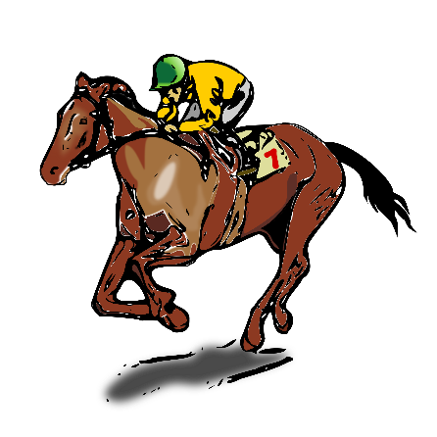

**Saturday, May 6th**

**9:00am – 12:00pm**

Come in & enjoy a day of shopping and betting on your favorite horse!

In-house horses will be chosen by shoppers with the winner being awarded a special prize.

Make sure to wear your fancy Derby Picture Hat or

Fascinator to be entered into a drawing.

Shopping, betting, and looking beautiful is exhausting &

requires a refreshing drink …. try-out our mocktail Mint Juleps!



Pelham Community Thrift Store at the Hobbs Community Center

8 Nashua Rd., Pelham NH 03076 603-635-3800 ext. 1